United Utilities WPM AMC Report

23rd July 2012

General Update for year 2011 to 2012

- Our present team format has changed in the fact that we now cover a slightly different area than last year and we have now amalgamated with our Headworks team who manage the Reservoirs and dams. Our land agents now sit with our property arm, but still operate out of our Rivington Offices.
- United Utilities are at present rebranding and you will be seeing new signage in and around our estates over the coming months.
- Scamp 2 has continued at a pace. Sustainable Catchment Management Plan is where we are trying to restore and re-wet the surrounding moorlands, create new woodland cloughs, protect biodiversity and provide a better grant income for our Farm tenants. We have now delivered or partly delivered on 19 of the 31 farm plans.

Please see attached update.

UNITED UTILITIES PLC

Committee: | SCaMP Programme West Pennine Moors Report
Date: | 16th July 2012
Report by: | Glynn Haworth ( SCaMP 2 Project Officer)
Subject: | West Pennine Moors and West Area ( formerly Central area)
- Nineteen of the 31 Central Area SCaMP plans have been approved and six small projects for Land at Cowpe, Buffs, Leys End, Lower Roddlesworth, Buffs and Land at Far Pike Lowe have been completed.

- The projects for Springmill, near Rochdale will be complete when minor pieces of fencing are completed. Ryals Fold near Tockholes is also complete except for a crossing point, fencing alterations and a hedgerow. All the woodland and moorland restoration at Musbury has been completed. The only outstanding item in this project is the spreading of BeadaMoss in a small area to try to encourage the establishment of sphagnum mosses. It is likely this work will be undertaken by staff from Natural England as part of a planned ‘awayday’.

- A further two small VSP projects for Land at Higher Hill and Land at Clowbridge have recently been approved and are currently being implemented.

- Wareings have provided a design and costs for the construction of the new midden roof at Higher Roddlesworth. Ecology surveys have been complete but planning permission for the structure cannot be progressed until Wareings produce acceptable annotated drawings with the structure in the correct location. The work will be re-priced and undertaken following the appointment of new framework contractors for agricultural buildings. The building construction element of this project is now therefore likely to be progressed in the autumn of 2012.

- A significant amount of the work at Bradleys Farm has now been completed though there will be savings on the approved budget as a result of the stakeholder statutory consultation and removal of the tree planting in the Biological Heritage site. The detailed location of a new water trough system is being reviewed to incorporate the potential of supplying additional fields that are currently part of Moses Cocker Farm.

- Work is progressing well at Cadshaw Farm with £217k spent on grip blocking, fencing and woodland planting. Modifications were made to some of the scope of woodland fences during construction at the request of the tenant which increased costs. However this provides additional protection to watercourses and will result in extra capital income arising from the additional area of EWGS woodland. Discussions on internal modifications to an existing building to act as a lambing shed are now progressing with good input on the requirements from the tenants. When cattle are put out to pasture modifications will be made across a building access to improve rainfall drainage to prevent it running through the concrete yard and overfilling the existing the dirty water tank. HLS grant submissions have been for approximately £23k.

- The majority of work at Higher Pasture House including grip blocking, access track improvements and a crossing point has been completed. Natural England has paid an extra £14k towards the grip blocking and a cheque is to be collected form the tenant. Rossendale Borough Council will also be providing a £14k grant from the Scout Moor Wind Farm Fund imminently.

Further fire break mowing is planned in future years.

- Drawings have been completed by Wareings for the new stock building at New Barn which has now been approved by the tenant. However these drawings are not detailed enough to allow them to be submitted for planning permission. A phase 1 habitat survey has been completed which has identified the presence of nesting owls which will not be impacted by the proposals. This may be sufficient for the planning permission to be submitted. It was expected the building would be progressed as a design and build project by Wareings and we have received a quote. The cost of the new building has now been tendered for as part of the SCaMP Agricultural Buildings framework. We await appointment of the framework contractor to progress this work within the existing approved budget.

- At Watsons Farm the proposals to install a new water trough system is on hold pending resolution of the proposals to address a borehole concessionary supply system that supplies farm properties in the area. The tenant's agent has now submitted a HLS application for the Land at Piccadilly which forms part of this tenancy and we have now raised orders to undertake the grip blocking and fencing on this piece of land.

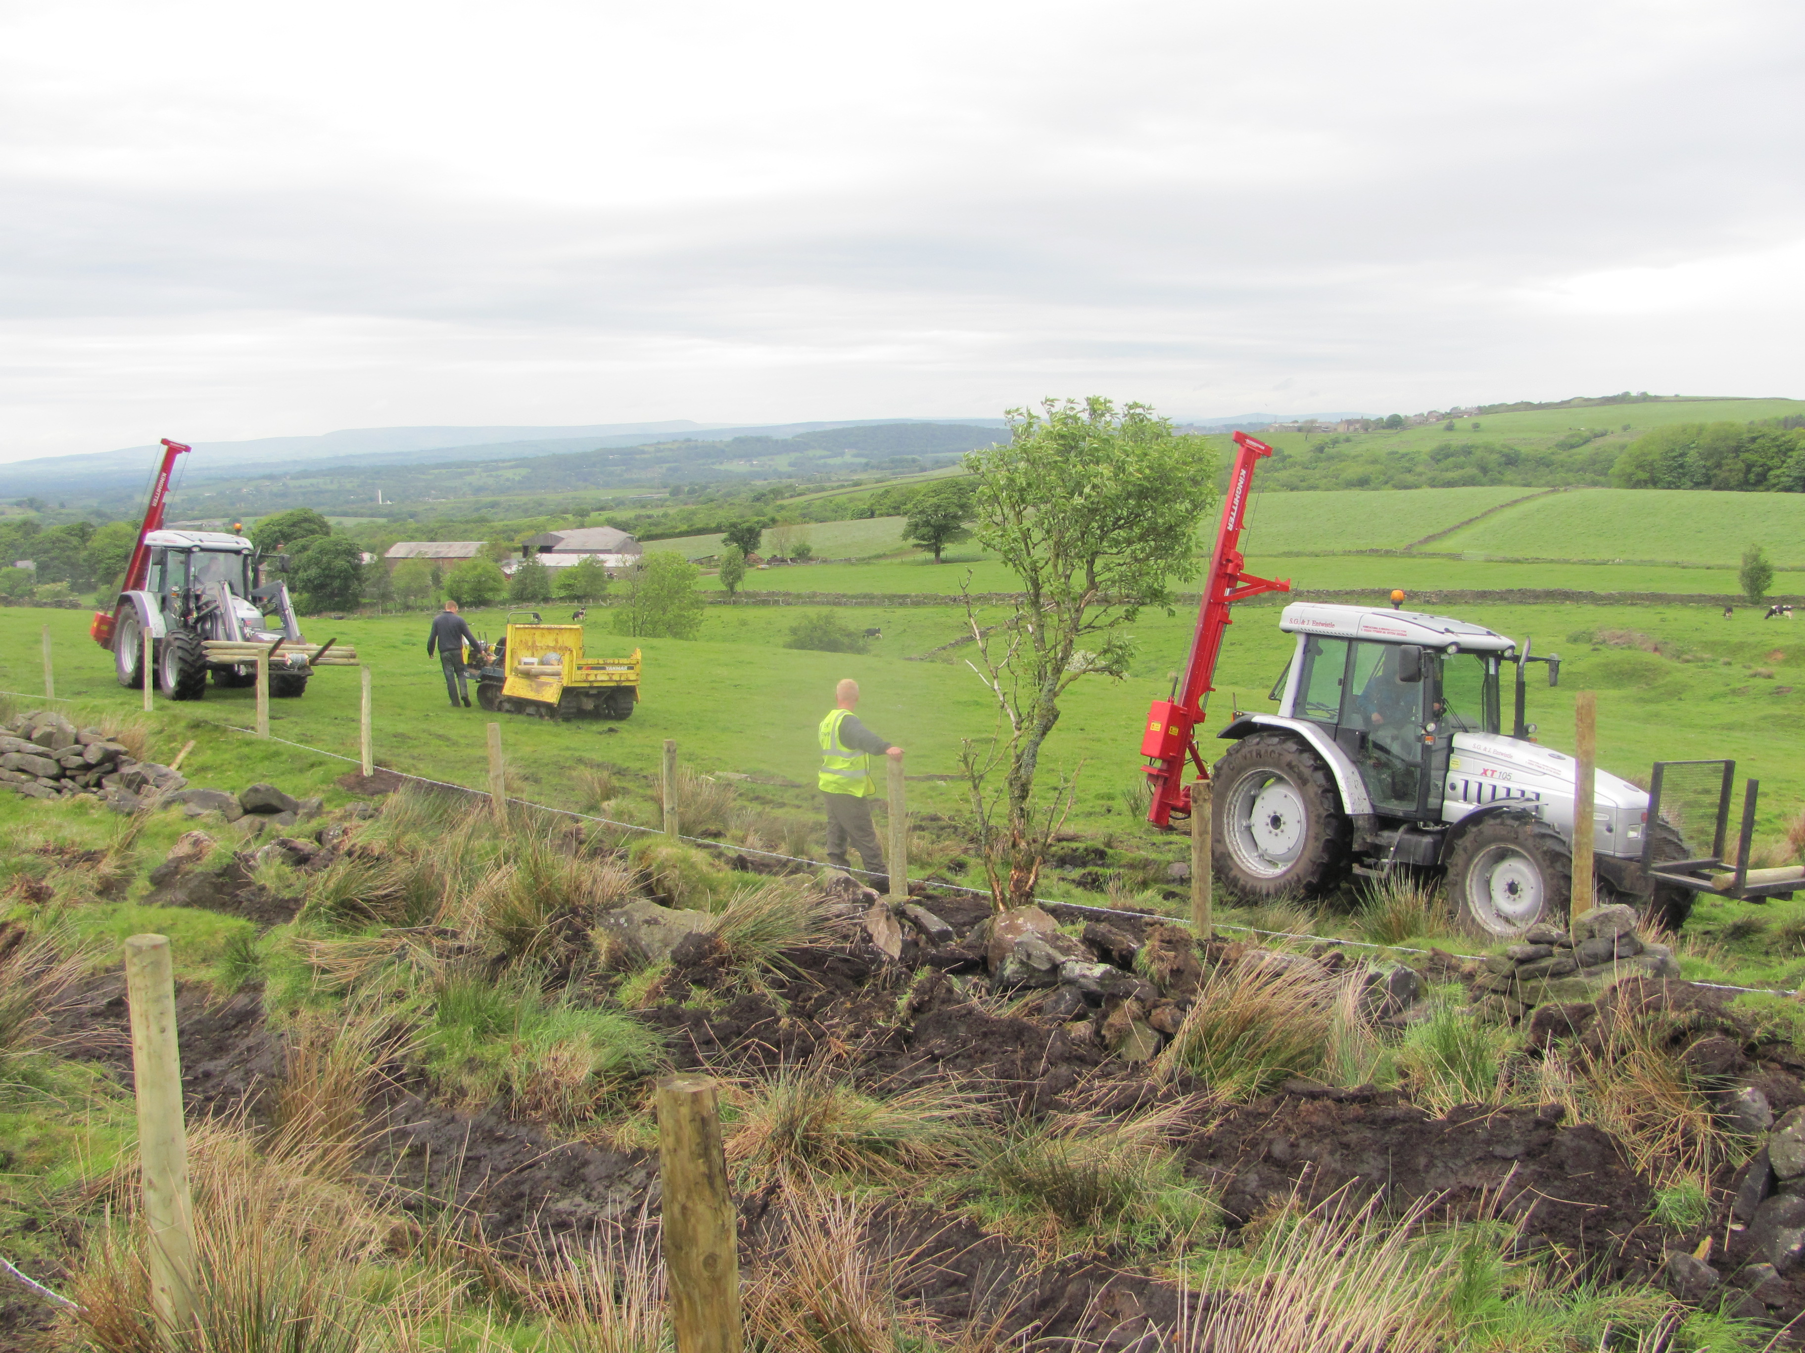

- UU took vacant possession of Moses Cocker Farm. The farm buildings have been independently valued with vacant possession. UU have developed the proposals for watercourse protection and adjoining UU tenants have tendered for the available land. An EWGS woodland plan is to be developed by the catchment team independently of SCaMP which will include fencing and re-wilding. This will result in cost savings for SCaMP but reduce the amount of capital grant

- To address two high risk items at Higher Knoll PRG funding was approved to allow a proposed footpath restoration to be fully scoped and costed as well as the proposals for a new farm building to be developed. A detailed scope of footpath restoration has now been received and UU are likely to fund a water quality element of the total cost as part of a ‘Three Towers’ Heritage Lottery Fund bid by Lancashire Wildlife Trust for the West Pennine Moors. The tenant is ready to sign up an HLS agreement for a 1st June start. Discussions are urgently required with the tenant and a building surveyor on the location and scope of the new building in order to progress this project through to planning permission and business approval. Details are needed of all the capital works and the grants proposed.

- A meeting was held with the tenant of Manor House and his agent before Christmas and the whole area walked to agree the exact location of the fencing. In order for the tenant to lamb all his sheep off catchment a bigger building is required than proposed in the draft plan. The scope of the ground works elements of the SCaMP plan is now being costed and a HLS application has now been submitted to Natural England. The scope and costs of the proposals for the new building now need to be developed with the support of Property Services so that an environmental impact assessment can be undertaken and planning permission sought to allow the project to be taken for major capital approval. In addition the potential inclusion of the Spitlers Edge footpath needs to be determined. Currently this footpath is to be included in the Three Towers Heritage Lottery Funding bid being led by the Wildlife Trust which may require an element of partnership funding.

- The FEP for Barons Fold has been completed and submitted to Natural England in order to progress the Higher Level Stewardship application. The work includes woodland creation, watercourse protection, grip blocking and fire breaks. It is anticipated that Natural England will use their LIDAR to undertake a ground penetrating survey to establish the location of peat pipes to be addressed by the project.

- The majority of the scope items for Land at Willowfield, Cowpe are ready including the scope of the fencing and woodland proposed. However project approval will be delayed until the location, scope and cost for a 3 bay lambing shed are agreed. The tenant has agreed to the transfer of an existing 3 year old farm building from Moses Cocker farm which needs to be removed as part of the planning approval. Costs have now been provided for dismantling, transferring the transfer and erection at the new site.

- The tenant at Wilcocks Farm has been unable to establish enough points to allow them to enter a HLS scheme. However they have previously agreed to the scope of the groundwork proposed in exchange for a new building. The detailed scope and costs of the building now need to be urgently progressed.

- The Catchment teams have been busy preparing grant applications for work undertaken in 2011/12 which include the payments requested below:

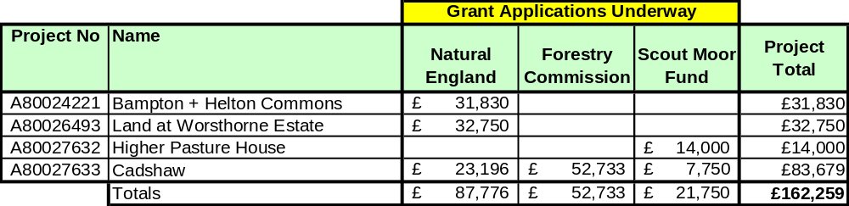

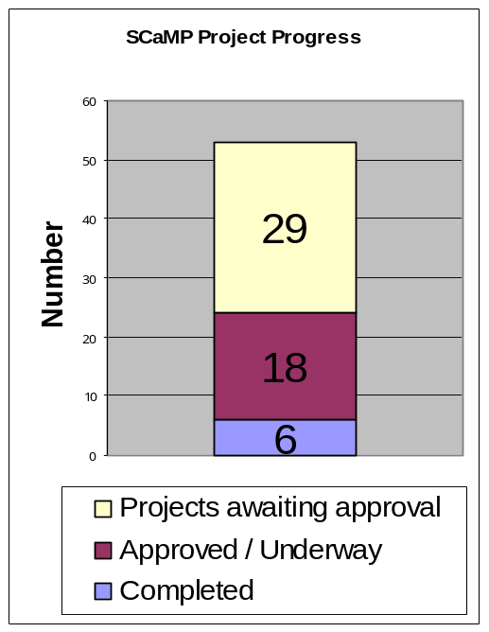
- The regulatory outputs are to deliver work across 30,000 ha of catchment land and list 20 WTW. SCaMP will be undertaking work on 16 of these WTW catchments. There is no work to undertake on the minor pieces of land we own at Ennerdale, Cornhow and Poaka Beck. Hodder WTW was listed in error.

- Approval of 3 projects at May 2012 SCaMP Programme Board will bring the total number of projects to 27 which is over half the total number of projects.

- Eleven of the remaining 26 projects cannot be progressed without significant input by a building surveyor

- UUs' submission to Natural England to support the inclusion of SCaMP in the NEP suggests we will carry out investigations into the impact of land management changes on carbon fluxes and their relationship to water quality changes. Durham University has been engaged to model the impact of SCaMP catchment management on greenhouse gases and carbon. They have completed improvements to their model and now have all the livestock and woodland data associated with SCaMP to input into the model. They have also offered to include carbon modelling for the work being undertaken at Kinder and Woodhead.

5. WATER QUALITY, HYDROLOGY AND BIODIVERSITY MONITORING

- The monitoring for the existing SCaMP1 contract with Penny Anderson Associates ended in Dec 2010. Paper copies of the Executive Summary and CDs with the remaining volumes were provided for the National Stakeholder Group meeting on the 22nd November. These reports have now been placed on the external website.

- In order to further justify the benefits of catchment management to our regulators Cranfield University has completed a review of the treatability of colour following moorland restoration. The results suggest that it may take much longer than expected following moorland restoration for the challenging colour compounds that water treatment processes do not remove to decline. Further work needs to be considered to understand the treatability of colour further.

- A new database has been created and trialled to capture events and interventions by Catchment Ops via the WQ Infobank. This has been launched within Catchment Operations in order to capture catchment management work including that carried out in prior years.

PUBLIC RELATIONS AND COMMUNICATION UPDATES

- Information has been provided to the communications team in order to update both the internal and external UU websites. The external website has undertaken a major overhaul and although some changes have been made to the SCaMP web page a significant amount has yet to be updated.

- The IUCN had their 2012 conference at Brockholes Nature Reserve near Preston with a theme of UK Protected Areas. UU supported the conference on the 27th April by providing them with opportunity for delegates to visit the work undertaken in SCaMP1 within the Bowland area.

- Rivington Heritage Trust report attached.


Rivington Heritage Trust
Briefing Note: June 2012

At the last meeting of the Board of the Rivington Heritage Trust (RHT) on 22 June 2012, the following items were discussed:

- Councillor Kim Snape was welcomed to her first meeting. Councillor Snape represents Chorley Council in replacement of Councillor Pat Case. B Homan from United Utilities was confirmed as Chairman in replacement of John Sanders. The Rivington Heritage Trust Board gave a vote of thanks to Councillor Case and John Sanders. It was noted that United Utilities had appointed a new Trustee, Andrew Turner. Two representatives of the Community Forum were also welcomed to the meeting as observers.

- The Community Forum had been formed and a couple of meetings had taken place. The Board were pleased with the progress and input that they had made so far particularly in the formation of some headline findings for further consultation within the Gardens.

- The partnership between RHT and Groundwork to a “Stage 1” bid for Heritage Lottery Funding continued. The Board were shown a powerpoint presentation by Groundwork which showed consultation and activities that had taken place so far. The Board agreed to the preparation and submission of the “Stage 1” bid in August 2012.

- The Board discussed the need for extensive research, interpretation and education. The intention was for schools and Higher Education institutions to become involved. There was also huge potential for volunteering opportunities within the Gardens which would be actively encouraged.

- It was noted that 56 questionnaires had been received so far and these continued to be available at Chorley, Adlington and Horwich libraries. It was noted that there was no deadline date for completion.

- An update on the Rivington Heritage Trust website was given. It was agreed that photographs and a brief profile of the Trustees would be added. The briefing note, the Rangers report and an overview of the progress of the HLF application would also be posted. The static website page is available at www.rivingtonheritagetrust.co.uk. Comments/questions about Rivington Heritage Trust and the proposed HLF application for the Terraced Gardens can by emailed to: info@rivingtonheritagetrust.co.uk.

- Traffic management within Lever Park and Rivington Village remains a concern to the RHT Board and the local community. The Board would welcome any comments or suggestions for ways to help improve the traffic issues that occur at peak times.

- United Utilities Water PLC reported the completion of health and safety work at Liverpool Castle. Some of the stones had been straightened and underpinned. Some sunny spells had led to swimming in the reservoir. UU had been working with the emergency services to hi-light the dangers of this. There had also been a press exercise at Jumbles reservoir on Monday 18th June to publicise how dangerous this activity is. There had been some vandalism in the Kitchen Gardens. Some of the fruit trees had been damaged. New interpretation signs were on site.

Rivington Heritage Trust
22 June 2012

Visit our new website at: www.rivingtonheritagetrust.co.uk

- Good Friday in Rivington was relatively uneventful with the weather keeping numbers lower than usual. Several thousand people walked up to the Pike that day, UU Rangers, local Police and Bolton Mountain Rescue were all in the area in the event of any issues occurring.
- Joint working with United Utilities and Pennine Prospects secured Heritage Lottery Funding for estate improvements at our Worsthorne estate, with car park improvements at Long Causeway car park, provision of a purpose built mountain bike track at Hurstwood, restoration of built heritage and Moorland restoration on Stipeden moor.
- Rivington has had two mayor projects undertaken, within the Park this year. The main drive between the barns having had new drainage and petrol / oil interceptors installed and a complete resurface of the tarmac. Also extensive repairs and improvements were made to the Castle with many on the unstable top stones being fixed into place to prevent further vandalism and many of the climbing points, being made more inaccessible to prevent access onto the castle walls and turrets. At present the Terraced Gardens are being assessed by English Heritage for an upgrade in listing status.

Please see attached report.
Case Name: Rivington Gardens
Case Number: 470593
Background
An application to amend the designation of Rivington Gardens PAG from Grade II to II* has been received, precipitated by encouragement from the English Heritage Historic Landscape Inspector who is of the opinion that the quality of this designated landscape is not reflected in its current Grade II listing. A charitable trust has been set up with the aim of enhancing the designated and undesignated heritage assets and the gardens for the benefit of the local community. The trust is looking to secure funding from a number of sources.

The application also includes a request to assess a number of contemporary currently unlisted structures within the garden. This application has been given a separate case number – UID 470595.

The opportunity is also being taken to re-assess the contemporary structures within the garden that are currently listed at Grade II. This re-assessment has been given a separate case number – UID 470594. It includes List Entry Nos. 1072506 – Lever Bridge in Lord Leverhulme's Terraced Gardens at SD 638 142; 1317582 – Loggia Circa 70 Meters West of Pigeon Tower in Lord Leverhulme's Terraced Gardens at SD 639 143; 1317613 – Pigeon Tower at North East Corner of Lord Leverhulme's Terraced Gardens at SD 639 143; and 1362123 – Two Archways and Associated Retaining Walls To Two Stone Staircases at North Corner of Tennis Lawn in Leverhulme's Terraced Gardens at SD 639 142.

Asset(s) under Assessment
Facts about the asset(s) can be found in the Annex(es) to this report.
Annex Name Heritage Category 1 RIVINGTON GARDENS Park and Garden

Visits
Date Visit Type
08 February 2012 Full inspection

Annex 1
The factual details are being assessed as the basis for a proposed addition to The National Heritage List for England.

Factual Details
Name: RIVINGTON GARDENS
Location
Rivington Gardens, Chorley, Lancashire. County District District Type Parish Lancashire Chorley District Authority Rivington

History
Rivington Gardens was one of a series of three major private gardens produced by Thomas Hayton Mawson (1861-1933) in collaboration with the industrialist and philanthropist William Hesketh Lever, Lord Leverhulme (1851-1925), the others being The Hill, Hampstead, London, begun in 1906, and Thornton Manor, Thornton Hough, Merseyside, also begun in 1906. The Rivington site was purchased by Lever in 1899 as a parcel of land which included the area now occupied by Lever Park to the west. Lever had already formulated ideas on how the grounds might be developed and in 1901 a single-storey wooden bungalow called 'Roynton Cottage' and intended for weekend visits and shooting parties was designed by Lever's school friend Jonathan Simpson. In 1905 Lever met Mawson who collaborated with him in the design of the gardens over the period 1906-22. However, others were also involved in the design including Thomas's son, Edward Prentice Mawson (1885-1954), who undertook the overall design and in the latter years was as much responsible for the project as his father, Robert Atkinson (1883-1952) who drew illustrations in the journal 'Civic Art' in 1911, and the landscape and architectural firm of James Pulham & Son who, in 1921, were responsible for a Japanese style garden and a steep and rugged ravine with waterfalls. Lever himself also influenced the gardens' layout, designing a seven-arched bridge across Roynton Lane.

In 1913 the bungalow was destroyed in an arson attack by the suffragette Edith Rigby. When rebuilt in stone it was a place for entertaining with a circular ballroom, glass-roofed pergola and winter garden. Following Lever's death in 1925 the house and gardens were purchased by John Magee. After Magee's death in 1939 the site was acquired by Liverpool Corporation and in 1948 the bungalow and four entrance lodges were demolished and the gardens became open to the public. In 1974 the site passed to the North West Water Authority following local government reorganisation. Rivington Gardens was first registered within the Historic Parks and Gardens Register at Grade II on 1 April 1986.

Four structures within the gardens were listed at Grade II on 30 January 1987: these were the Pigeon Tower at the North-East Corner of Lord Leverhulme's Terraced Gardens at SD639143, Lever Bridge in Lord Leverhulmes Terraced Garden at SD638142, Loggia c.70 Metres West of Pigeon Tower in Lord Leverhulme's Terraced Gardens at SD639143, and Two Archways and Associated Retaining Walls to Two Stone Staircases at North Corner of tennis Lawn in Leverhulme's Terraced Gardens at SD639142.

Details
LOCATION, SETTING, LANDFORM, BOUNDARIES AND AREA
Rivington Gardens is situated on the steep slopes of Rivington Moor on the western edge of the West Pennine Moors from where there are extensive views westwards to the coast and beyond to the mountains of North Wales to the south-west and the Lake District to the north-west. The site overlooks Lever Park and the reservoirs in the valley to the west and is itself overlooked by higher ground to the east which is topped by Rivington Pike Tower (1733, listed Grade II). The gardens are bounded by fences along the north, west and south sides.

At the south east corner the boundary line projects across a former entrance then follows a fence on the west side of Belmont Road. Near the north east corner of the site the boundary line projects across a former entrance then follows the roadside verge and fence for a short distance on the west side of a lane adjacent to the Pigeon Tower. The gardens cover approximately 18ha.

ENTRANCES AND APPROACHES
There are three main entrances to the gardens, all of which originally had lodges now demolished. At the north-east corner of the site there is an entrance off Belmont Road adjacent to the site of the former Belmont Lodge that is marked by circular stone piers. At the south east corner of the site there are similar gate piers and a C20 toilet block has now been erected on the site of the former Bolton Lodge. The upper drive connects both these entrances and leads to the site of the former bungalow. The third entrance is situated close to the north west corner of the site where a path leads across a meadow from Rivington Hall to a modern metal gateway. South Lodge was formerly situated to the north of this gateway. This gateway leads to a system of narrow paths and stone steps through woodland forming part of the gardens. Another principal means of accessing the site is via Roynton Lane which runs north – south and bisects the site. A further lodge, Stone Lodge, was situated off this drive some 200m south-west of the bungalow site. It has been demolished and the entrance is marked by a pair of circular stone piers. A drive runs in a horseshoe shape from Roynton Lane at this point to join the upper drive close to the site of the former bungalow. There are a number of pedestrian entrances from paths around the site.

PRINCIPAL BUILDING
The bungalow, known as Roynton Cottage, was situated on a hillside platform close to the north-east corner of the site. It was initially a prefabricated wooden house erected in 1900/01, supplied by a firm in Manchester, and described by them as a shooting box. After destruction in an arson attack in 1913 it was rebuilt in stone on a much grander scale and incorporated features such as a circular ballroom, music gallery, glass-roofed pergola, winter gardens, kitchen, dining room, lounge, morning room, library, study and servant's quarters. It was demolished in 1948.

GARDENS AND PLEASURE BUILDINGS
The gardens fall into two distinct areas: the area east of Roynton Lane with the site of the bungalow, and the pleasure grounds on the west side of the lane. The garden area is more formal with open lawns and lakes, and contains a range of vegetation that formed part of Mawson's ornamental planting including species such as Berberis, Gaultheria, Rhododendron, cherry laurel and hollies etc. By contrast the area west of Roynton Lane slopes more steeply and is wholly planted with trees such as sweet chestnut, beech, lime, Scots pine, hybrid larch, rowan, sycamore, oak and birch. Unifying features between the two areas are the use of terrace paths formed from irregularly-shaped and set flags, dressed rubble walls, flights of stone steps, and a distinctive architectural style for garden shelters and pavilions characterised by classical style and the use of dressed rubble, with the emphasis on contrasting masonry sizes ranging from narrow flags to squared blocks.

The site of the former bungalow is a level platform situated west of a wooded terrace which slopes down from Belmont Road to a stone retaining wall along the upper drive. A terraced walk is situated on the south-west side of the platform, and on the north side a flight of stone steps, called the Orchestra Steps, leads down to a square lawn set diagonally to the slope of the land. A path leads north from the lawn past a small pool with rockwork and a rusticated statue base approximately 60m from the bungalow site, and upwards to a tall, French Gothic-style building called the Pigeon Tower (by R Atkinson 1910, listed Grade II), some 150m north-east of the bungalow site. Views of Rivington Pike Tower (listed Grade II) to the south-east can be obtained from this part of the gardens. At the north-east corner of the lawn there is a pair of stone staircases leading down to two stone archways (listed Grade II) which connect with steps down to an area where a former swimming pool/boating lake is situated some 100m north of the bungalow site. This area is known as the Italian Gardens. On one side the lake is framed by rockwork cliffs and a waterfall. It is overlooked on its northern side by an arcaded loggia (listed Grade II) which has steps up to a rooftop platform giving views over the lake and across wooded slopes to the west. A balustraded walk leads east from this observation point to steps up to a summer house. The remains of another arcaded pavilion are situated immediately north of this and steps lead up eastwards from this to the Pigeon House. A path on the west side of the former swimming pool/boating lake leads south along the edge of a terrace to an area called the Great Lawn. About 50m south of the lake a flight of stone steps leads west from the path down the slope towards Roynton Lane and passes a summer house with paired Tuscan columns. The Great Lawn is overlooked by a summer house set into the slope on its east side. This has paired Tuscan columns and a balustraded viewing platform on the roof with steps leading from this to the terrace above. A similar lawn, the site of a former tennis court built in 1906, with a similar summer house, is situated to the south of this and the two areas are divided by a long flight of stone steps, called the Long Walk, which leads upslope from a drive about 20m south-east of the site of Stone Lodge, connecting the lower terraces to the upper drive. All these parts of the garden conform closely to a plan published by Mawson in 1912, though this does not show details of the structures. Between the kitchen garden and Roynton Lane, approximately 350m south west of the site of the bungalow, is the Japanese Garden: this consists of a lake fed by a waterfall which falls over steep rockwork cliffs on its west side. Views of Rivington Pike Tower to the east can be obtained from the lakeside. Three Japanese-style pavilions or tea houses formerly situated in this area, and depicted on photographs of about 1930, have been demolished and only their stone bases remain. The garden was created in 1921-2 and was inspired by a visit Lever made to Japan in 1913.

The area west of Roynton Lane consists of a steep wooded slope which is terraced, with paths running along the terraces. The area was formed from woodland called Hall Closes which is depicted on the 1st edition Ordnance Survey map surveyed in 1845-7. On the north side of the site an ornamental arched footbridge called Levers Bridge (listed Grade II), said to have been designed by Lever himself, crosses Roynton Lane and connects with steps leading upwards past two summer houses towards the swimming pool/boating lake to the east. A system of paths and stone steps leading down to the west connect with the path from the South Lodge entrance and to the terraced paths leading north/south across this part of the site. Some 350m south of Levers Bridge, on the lowest terrace, there is a summer house of similar design to those in the gardens. Steps lead up on either side of this and continue east up the slope serving to connect the terrace paths. A steep gorge called The Ravine is situated towards the southern end of the site. This feature was created in 1921 when natural streams across the site were diverted to fill the lake in the Japanese Garden and then to continue westward down the slope forming a series of cascades and waterfalls. Two bridges carry footpaths across the Ravine; the upper one which is situated about 80m west of the Japanese garden, is a simple stone arch, while the lower one has stone balustrades. Dramatic views of the waterfalls and adjacent rock formations are obtained from the bridges and from a crossing point formed by stepping stones midway between them.

KITCHEN GARDEN
The kitchen garden is situated immediately south-east of the Stone Lodge entrance from Roynton Lane, about 200m south of the bungalow site. It consists of a series of four partially ruinous stone-walled compartments, the north end bay of which was formerly occupied by a glasshouse, together with a small group of ruined buildings that comprised a bothy, toll and potting sheds, store shed, small stable, fernery, boiler room and garage.

Selected Sources
C J Holme, Gardens of England in the Northern Counties, 1911 Janet Waymark, Thomas Mawson: Life, Gardens and Landscapes, 2009 M D Smith, Leverhulme's Rivington, 1984 N Pevsner, The Buildings of England: North Lancashire, 1969 T H Mawson, The Art and Craft of Garden Making, 1912 (4th ed) 6" to one mile, 1929 edition with additions 1938 6" to one mile: 1st edition, 1845-7 Mountain Home and Garden, Rivington, Lancs, 1912 Lever Park Management Plan, (Pauline Roscoe Associates) 1996.Lever Park: A Strategic Review (Cobham Resource Consultants, c.1989

- Bolton Conservation Volunteers (BCV) have continued with work in Rivington, their work on the wall located between Go Ape and Lower Rivington Reservoir has been ongoing. Some vandalism has occurred to the fruit trees within the Kitchen gardens in the terraced gardens and this will be picked up in the near future.
- Fly tipping continues to be a problem with numerous tyres, asbestos and rubbish dumped around our estates, the Police have been kept informed.
- Our Woodland plans that have been agreed and are now being delivered in close liaison with the Forestry Commission, will endeavour to reduce the non native conifer elements within our plantation and to promote native broadleaves and natural regeneration where possible. You will have seen some extensive roadside clearances where we will be introducing a native broadleaved shrub and woodland layer and also reduce any problems we may have encountered with trees falling onto roads and footpaths.
- Our Wildlife Warden Ian Harper has included this update:
- The current work programmes is attached and the capital programme for the WPMs will be available at the meeting.

